|  |  |  |
| --- | --- | --- |
| **LAB 321Assignment** | **Type:** | **LongAssignment** |
| **Code:** | **J3.L.P0033** |
| **LOC:** | **650** |
| **Slot(s):** | **15** |

**Title:** Local Community Church

**Background**

### You want to share your local Church to every one in the world ?

Complete this assignment to know how to do ☺

Reference site:<http://us-123-church.simplesite.com/>

**Program Specifications**

Program a web site tointroduce your Local Community Church, detail functions of this website is described below

**Features:**

This website contains 4 main functions

* Function 1 : Home page : ( see PIC 01)
  + Display introduction entry and short description
* Function 2 : Prayer ( PIC 02)
  + Display all topic about prayer including ( title , picture and content )
* Function 3 : Service ( PIC 03)
  + Display detail calendar of Local Community Church ‘service
* Function 4: Contact
  + Display contact information

You do not need to write interface for admin control panel, you can add data manually (use SQL SERVER Management studio).

Note: All data must be load from database, not hard code in page.

***Expectation of User interface:***

Pic 01 : Home Page

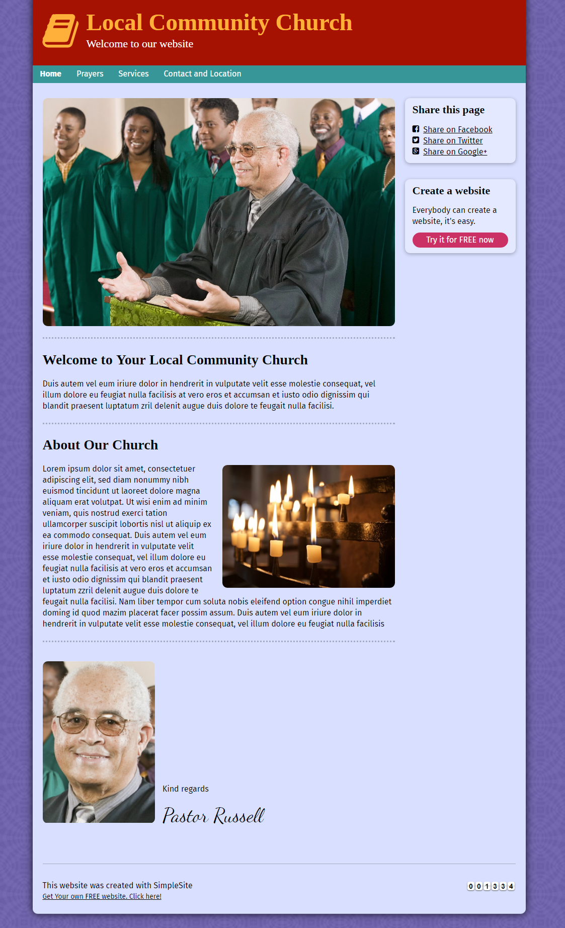

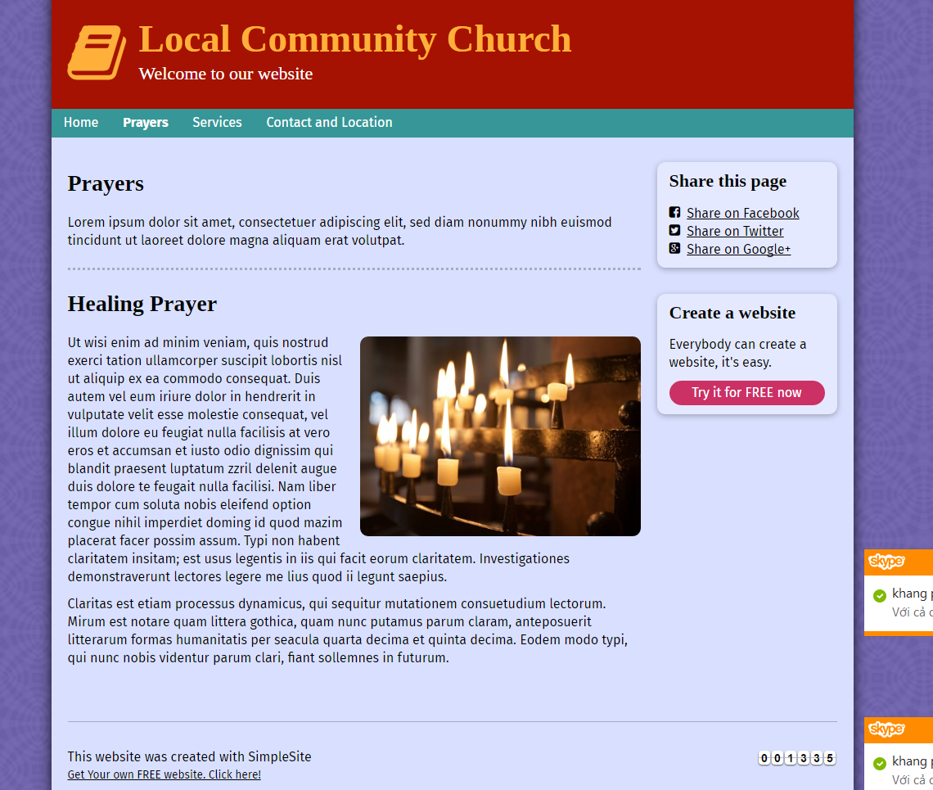

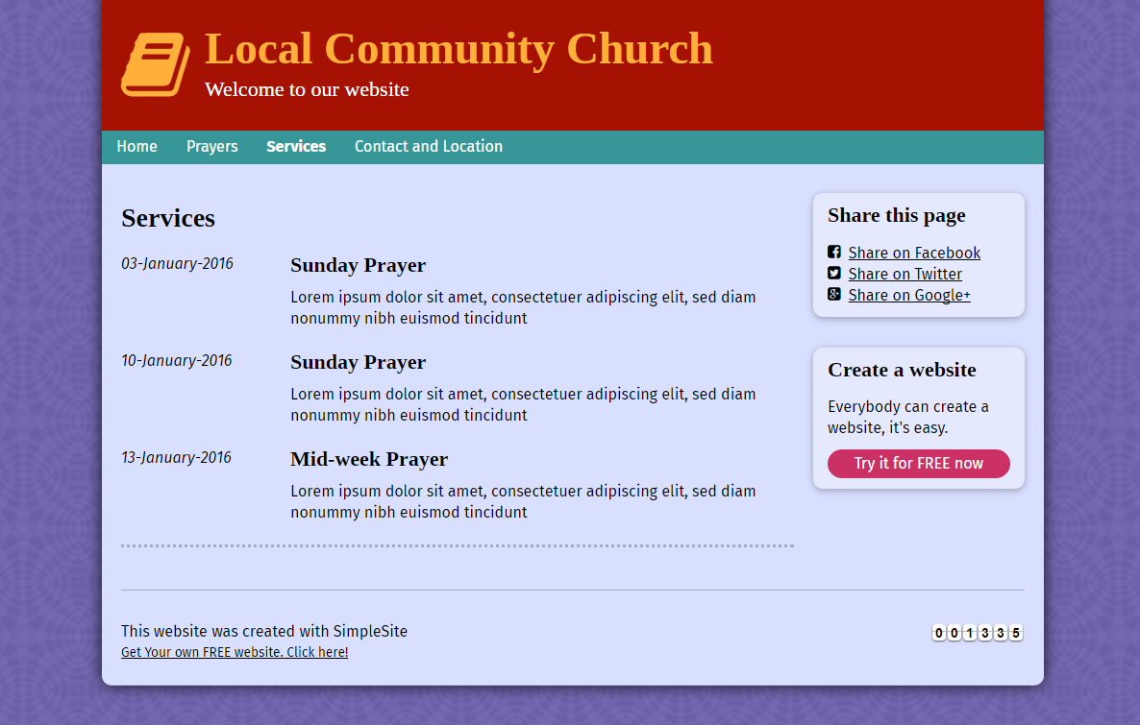

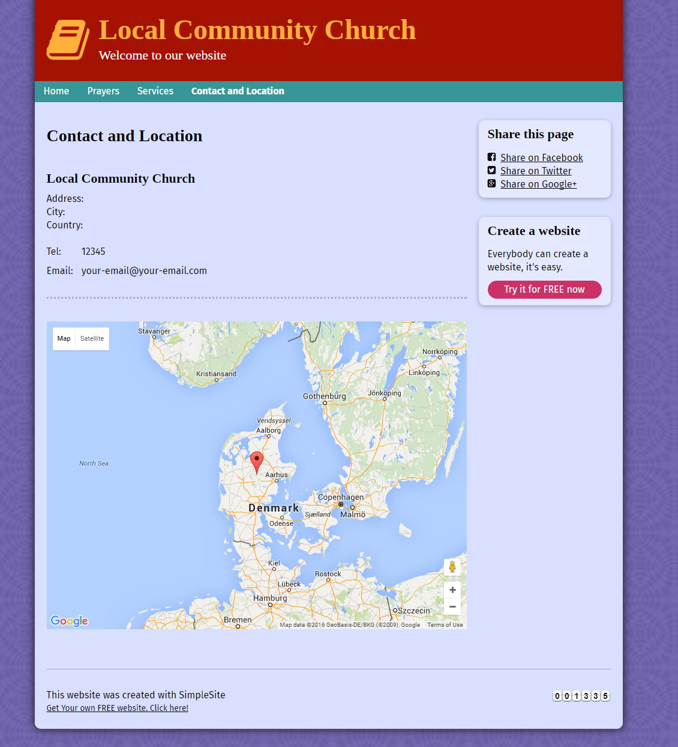

**Guidelines**

* Step 1 : Create web layout
* Step 2 : Create prototype
* Step 3 : Design database base on created prototype
* Step 4 : Code & Test